**ETE 4141L (Java) Laboratory #8**

**Objectives:**

* To understand the design principles of graphical user interfaces (GUI).
* To be able to build graphical user interfaces.
* To understand the packages containing GUI-related components.
* To be able to create and manipulate buttons, labels, lists, text fields and panels.

**Problem:**

1. Create a calculator panel as shown in the diagram below.
2. The panel should have buttons and a Text Field for display.
3. Add number buttons to the panel.
4. No action is required

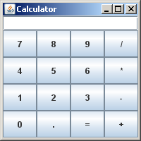

**No report is required for the Laboratory.**